EX. NO.: 24
TITLE
COLLEGE ADMISSION FORM
AIM
To create an online college admission form that generates an admission number for the candidate.

PROCEDURE
- Install the latest version of Python and MySQL.
- Install the required Python modules.
- Create the required database and table in MySQL.
- Establish a connection between Python and MySQL.
- Import the required modules.
- Create functions for new admission and updating existing details.
- Generate a unique admission ID for each candidate.
- Store the candidate details in the database.
- Provide an option to update the details using the admission ID.
- Execute the program and verify the output.

PROGRAM
1. Import Required Modules and Connect to MySQL
import tkinter as tk
import tkinter.messagebox as mb
import random
import tkinter.ttk
from tkinter import *
import mysql.connector as mysql

conn = mysql.connect(
host="localhost",
user="root",
password="",
database="MobileDB"
)

cursor = conn.cursor()

root = Tk()
root.title("COLLEGE ADMISSION")
root.geometry("500x400")

2. Create New Admission Form
def signup():

root.destroy()

entrypage = Tk()
entrypage.geometry('1000x1000')
entrypage.title("ADMISSION FORM")

label_0 = Label(
entrypage,
text="NEW ADMISSION",
width=20,
font=("bold", 20)
)
label_0.place(x=350, y=50)

Label(
entrypage,
text="First Name",
width=20,
font=("bold", 10)
).place(x=300, y=150)

firstname = Entry(entrypage)
firstname.place(x=500, y=150)

Label(
entrypage,
text="Last Name",
width=20,
font=("bold", 10)
).place(x=300, y=200)

lastname = Entry(entrypage)
lastname.place(x=500, y=200)

Label(
entrypage,
text="Age",
width=20,
font=("bold", 10)
).place(x=300, y=250)

age = Entry(entrypage)
age.place(x=500, y=250)

3. Gender Selection
Label(
entrypage,
text="Gender",
width=20,
font=("bold", 10)
).place(x=300, y=300)

gender = StringVar()

Radiobutton(
entrypage,
text="Male",
variable=gender,
value="M"
).place(x=485, y=300)

Radiobutton(
entrypage,
text="Female",
variable=gender,
value="F"
).place(x=550, y=300)

4. Date of Birth and Community
Label(
entrypage,
text="Date of Birth",
width=20,
font=("bold", 10)
).place(x=300, y=350)

dob = Entry(entrypage)
dob.place(x=500, y=350)

Label(
entrypage,
text="Community",
width=20,
font=("bold", 10)
).place(x=300, y=400)

list1 = ['OC', 'BC', 'MBC', 'SC', 'ST']

community = StringVar()

droplist = OptionMenu(
entrypage,
community,
*list1
)

community.set('Select your community')
droplist.config(width=20)
droplist.place(x=500, y=400)

5. State Selection
Label(
entrypage,
text="Select your state",
width=20,
font=("bold", 10)
).place(x=300, y=450)

States = [
"Andhra Pradesh",
"Arunachal Pradesh",
"Assam",
"Bihar",
"Chhattisgarh",
"Goa",
"Gujarat",
"Haryana",
"Himachal Pradesh",
"Karnataka",
"Kerala",
"Madhya Pradesh",
"Maharashtra",
"Manipur",
"Meghalaya",
"Mizoram",
"Nagaland",
"Odisha",
"Punjab",
"Rajasthan",
"Sikkim",
"Tamil Nadu",
"Telangana",
"Tripura",
"Uttar Pradesh",
"Uttarakhand",
"West Bengal",
"Puducherry"
]

state = StringVar()

droplist = OptionMenu(
entrypage,
state,
*States
)

state.set('Select your State')
droplist.config(width=20)
droplist.place(x=500, y=450)

6. Subjects Studied
Label(
entrypage,
text="Subject Studied in class 12",
width=20,
font=("bold", 10)
).place(x=300, y=500)

maths = IntVar()
physics = IntVar()
chemistry = IntVar()
biology = IntVar()
computer = IntVar()
english = IntVar()

Checkbutton(
entrypage,
text="Maths",
variable=maths
).place(x=500, y=525)

Checkbutton(
entrypage,
text="Physics",
variable=physics
).place(x=500, y=550)

Checkbutton(
entrypage,
text="Chemistry",
variable=chemistry
).place(x=500, y=575)

Checkbutton(
entrypage,
text="Biology",
variable=biology
).place(x=500, y=600)

Checkbutton(
entrypage,
text="Computer Science",
variable=computer
).place(x=500, y=625)

Checkbutton(
entrypage,
text="English",
variable=english
).place(x=500, y=650)
7. Total Marks
Label(
entrypage,
text="Total Marks Scored in 12th",
width=20,
font=("bold", 10)
).place(x=700, y=600)

marks = Entry(entrypage)
marks.place(x=900, y=600)

DATABASE
8. Create Student Table in MySQL
Run this in MySQL Workbench:
USE MobileDB;

CREATE TABLE IF NOT EXISTS Student
(
AdmissionID INT PRIMARY KEY,
FirstName VARCHAR(30),
LastName VARCHAR(30),
Age INT,
Gender VARCHAR(10),
DOB VARCHAR(20),
Community VARCHAR(10),
State VARCHAR(40),
Subjects VARCHAR(100),
Marks INT
);

9. Generate Unique Admission ID
admission_id = random.randint(10000, 99999)

mb.showinfo(
"Admission Successful",
"Your Admission ID is: " + str(admission_id)
)
10. Update Details Using ID
def update_details():

update_window = Tk()
update_window.title("UPDATE DETAILS")
update_window.geometry("500x400")

Label(
update_window,
text="Enter Admission ID",
font=("bold", 12)
).pack(pady=20)

id_entry = Entry(update_window)
id_entry.pack()

Button(
update_window,
text="Update",
command=lambda: mb.showinfo(
"Update",
"Enter details to update"
)
).pack(pady=20)

OUTPUTS
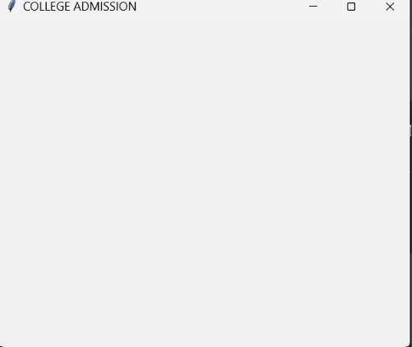
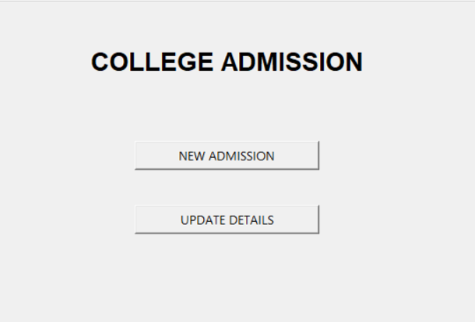
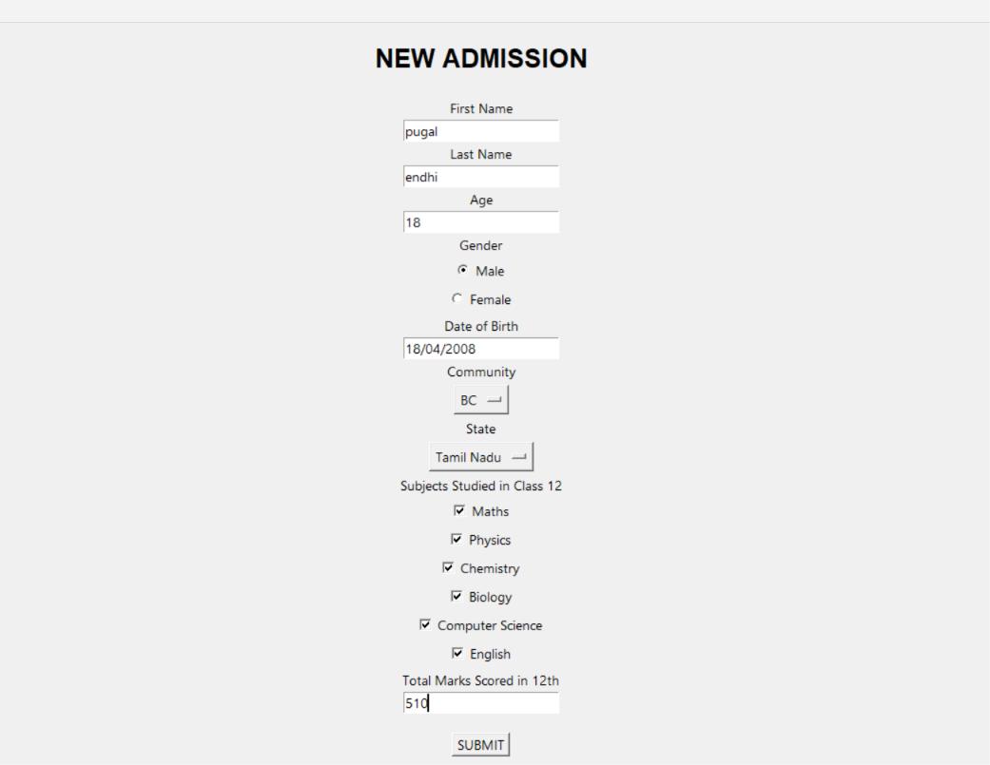
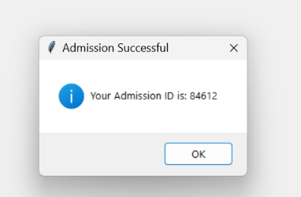

RESULT
Thus, the College Admission Form was successfully developed using Python and MySQL to generate a unique admission number and provide options for updating the candidate details.

